1.1

SElECT

CustomerID AS 'Customer ID',

CompanyName AS 'Company Name',

Address,

City,

Region,

PostalCode AS 'Postal Code',

Country

FROM customers

WHERE City IN ('Paris', 'London');

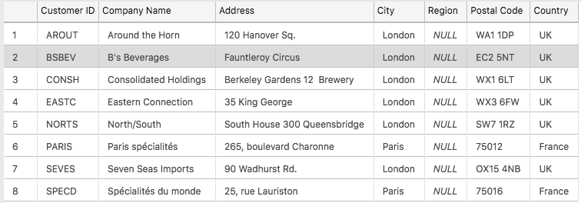

1.2

SELECT

ProductName AS 'Products Stored in Bottles'

FROM Products

WHERE QuantityPerUnit like '%bottles%';

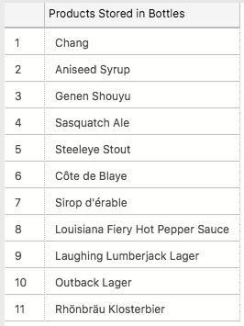

1.3

SELECT

ProductName AS 'Products Stored in Bottles',

Suppliers.CompanyName AS 'Company Name',

Suppliers.Country

FROM Products

INNER JOIN Suppliers ON Products.SupplierID = Suppliers.SupplierID

WHERE QuantityPerUnit like '%bottles%';

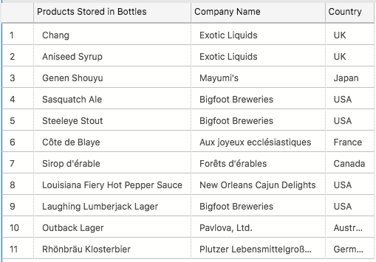

1.4

SELECT

products.CategoryID AS 'Catagory ID',

Categories.CategoryName AS 'Catagory Name',

COUNT (products.ProductID) AS 'Number of products' FROM Products

INNER JOIN Categories ON Products.CategoryID = Categories.CategoryID

GROUP BY products.CategoryID, Categories.CategoryName

ORDER BY [Number of products] DESC;

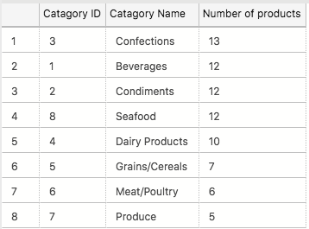

1.5

SELECT

CONCAT( TitleOfCourtesy, ' ', FirstName, ' ', LastName) AS 'Title. Full Name',

City

FROM Employees

WHERE Country = 'UK';

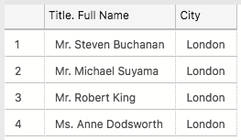

1.6

SELECT

Territories.RegionID AS 'Region',

FORMAT (SUM ([Order Details].UnitPrice * [Order Details].Quantity * (1 - [Order Details].Discount)), 'c', 'eng-us') AS 'Total price'

FROM Territories

INNER JOIN EmployeeTerritories ON Territories.TerritoryID = EmployeeTerritories.TerritoryID

INNER JOIN Orders ON EmployeeTerritories.EmployeeID = [Orders].EmployeeID

INNER JOIN [Order Details] ON Orders.OrderID = [Order Details].[OrderID]

GROUP BY Territories.RegionID

Having SUM ([Order Details].UnitPrice * [Order Details].Quantity * (1 - [Order Details].Discount)) > 1000000

ORDER BY Territories.RegionID;

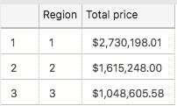

1.7

SELECT

COUNT (OrderID) AS '100+ Freight Cost, Destination UK or USA'

FROM [Orders]

WHERE Freight > 100.00

AND ShipCountry IN ('USA', 'UK');

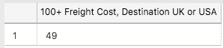

1.8

SELECT TOP (2)

OrderID AS 'Order Number',

UnitPrice * Discount * Quantity as 'Total Discount Amount'

FROM [Order Details]

ORDER BY [Total Discount Amount] Desc;

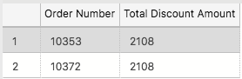

2.1

CREATE TABLE SpartansTable

(

primary_id INT NOT NULL IDENTITY PRIMARY KEY,

SeperateTitle VARCHAR(255),

FirstName VARCHAR(255),

LastName VARCHAR(255),

University VARCHAR(255),

Degree VARCHAR(255),

Mark VARCHAR(255)

);



2.2

INSERT INTO SpartansTable

(

SeperateTitle, FirstName, LastName, University, Degree, Mark

)

VALUES

(

'Mr.', 'Kit', 'Baker', 'University College London', 'Digital Humanities', '2:1'

);

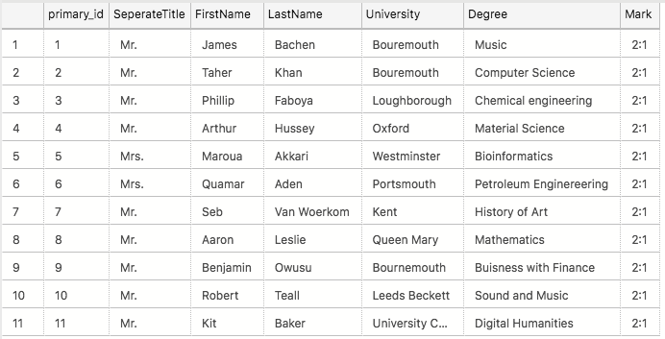

3.1

SELECT

CONCAT (employees.FirstName, ' ', employees.LastName) AS 'Employee Name',

CONCAT (E.FirstName, ' ', E.LastName) AS 'Reports To'

FROM Employees

Left OUTER JOIN Employees E ON Employees.ReportsTo = E.EmployeeID;

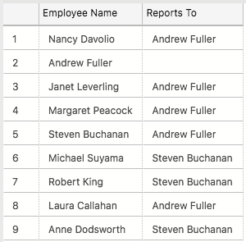

3.2

SELECT

Suppliers.[CompanyName],

ROUND (SUM([Order Details].UnitPrice * [Order Details].Quantity * (1- [Order Details].Discount)), 1) AS 'Total Sales'

FROM [Order Details]

INNER JOIN Products ON [Order Details].ProductID = Products.ProductID

INNER JOIN Suppliers ON Products.SupplierID = Suppliers.SupplierID

GROUP BY CompanyName

HAVING SUM([Order Details].UnitPrice * [Order Details].Quantity * (1- [Order Details].Discount)) > 10000

ORDER BY [Total Sales] DESC;

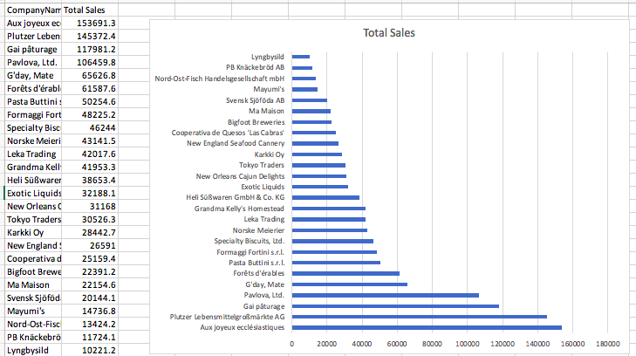

3.3

SELECT

TOP (10)

Customers.CompanyName AS 'Comapany Name',

FORMAT ( SUM([Order Details].UnitPrice * [Order Details].Quantity * (1 - [Order Details].Discount)), 'c', 'eng-us') AS 'Total Expenditure'

FROM Orders

INNER JOIN [Order Details] ON Orders.OrderID = [Order Details].OrderID

INNER JOIN Customers ON Orders.CustomerID = Customers.CustomerID

WHERE orders.OrderDate > '1997-05-06'

GROUP BY Customers.CompanyName

ORDER BY SUM([Order Details].UnitPrice * [Order Details].Quantity * (1 - [Order Details].Discount)) DESC

